End-to-End MLOps Pipeline for Heart Disease Risk Prediction
Course: Machine Learning Operations (MLOps) AIMLCZG523, BITS Pilani
Assignment: Assignment 01
Student: Sayali Venkatesh Padmawar
Student ID: 2025AE05064
Code repository: https://github.com/sayali1711/heart-disease-mlops
Demo video: https://github.com/sayali1711/heart-disease-mlops/tree/main/video

1. Introduction
This project builds a classifier that predicts the presence of heart disease from routine patient health data, and ships it as a containerised, monitored API using MLOps practices. The work covers data acquisition and EDA, model development with cross-validation, experiment tracking with MLflow, reproducible packaging, automated testing and CI/CD with GitHub Actions, Docker containerisation, Kubernetes deployment, and monitoring with Prometheus and Grafana.
The guiding design goals were:
- Reproducibility: pinned dependencies, a fixed random seed, and one pipeline object that holds both preprocessing and the model.
- Leakage-free evaluation: imputation and scaling are fitted only on training folds, and the final model is chosen on cross-validated metrics, not on the test set.
- Automation: every push is linted, tested, used to train the model, and used to build and smoke-test the Docker image.
- Observability: every API request is logged, and request, latency and prediction metrics are exposed to Prometheus.

2. Setup and Installation

2.1 Prerequisites
Tool | Version / note
Python | 3.11
Git | any recent version
Docker Desktop | with the engine running
Minikube and kubectl | or Docker Desktop's built-in Kubernetes
GitHub account | for the repository and GitHub Actions

2.2 Install and run locally
git clone https://github.com/sayali1711/heart-disease-mlops.git
cd heart-disease-mlops
python -m venv .venv
.venv\Scripts\activate
pip install -r requirements-dev.txt
On macOS or Linux, activate with source .venv/bin/activate.

2.3 Pipeline commands, in order
Step | Command | Result
1. Download and clean data | python scripts/download_data.py | data/raw/heart_raw.csv, data/processed/heart_clean.csv
2. EDA | python -m src.eda | figures in reports/figures/
3. Train and track | python -m src.train | models/model.joblib, models/metrics.json, mlruns/
4. View experiments | mlflow ui --backend-store-uri ./mlruns | UI at http://127.0.0.1:5000
5. Lint and test | flake8 src tests scripts and pytest --cov=src | quality gate
6. Serve locally | uvicorn src.api:app --port 8000 | API at http://localhost:8000/docs
7. Container | docker build -t heart-disease-api:latest . | image
8. Monitoring stack | docker compose up --build | API, Prometheus, Grafana

3. Data Acquisition and Exploratory Data Analysis

3.1 Dataset
The project uses the Cleveland subset of the UCI Heart Disease dataset. scripts/download_data.py downloads processed.cleveland.data from the UCI repository, adds the 14 column names, and saves it as a CSV. The dataset has 13 predictors and one target:
Type | Features
Numeric | age, trestbps (resting blood pressure), chol (cholesterol), thalach (maximum heart rate), oldpeak (ST depression)
Categorical | sex, cp (chest pain type), fbs (fasting blood sugar), restecg, exang (exercise-induced angina), slope, ca (major vessels), thal
Target | num, originally 0 to 4, converted to binary (0 = no disease, 1 = disease)

3.2 Cleaning
- Missing values are marked with ? in the raw file. They are converted to NaN, and the affected columns are ca and thal.
- All feature columns are coerced to numeric types and duplicate rows are dropped.
- The multi-class target is binarised: any value above 0 becomes 1.
- Missing values are deliberately not imputed during cleaning. They are imputed inside the model pipeline, so the statistics are learned from training folds only. This prevents data leakage.
Final dataset: 303 patients and 13 features. Class balance: 164 patients without disease (54.1%) and 139 with disease (45.9%), so the classes are close to balanced and no resampling was needed.

3.3 EDA findings
The EDA script produces a class-balance plot, histograms of the numeric features, and a correlation heatmap.
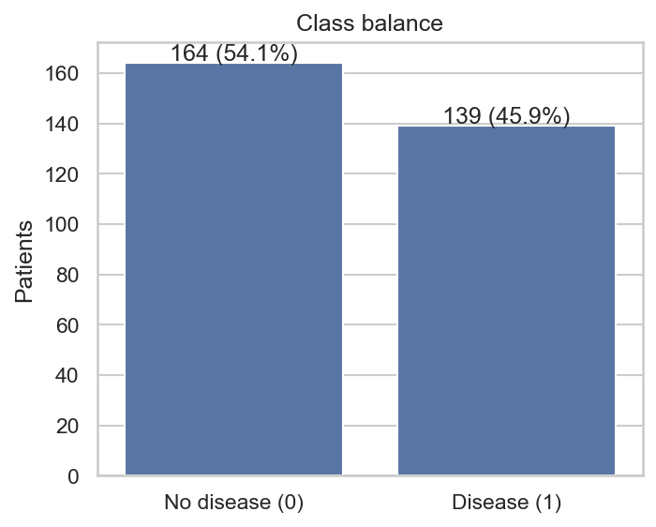
Figure 1. Class balance of the binary target: 164 without disease, 139 with disease.
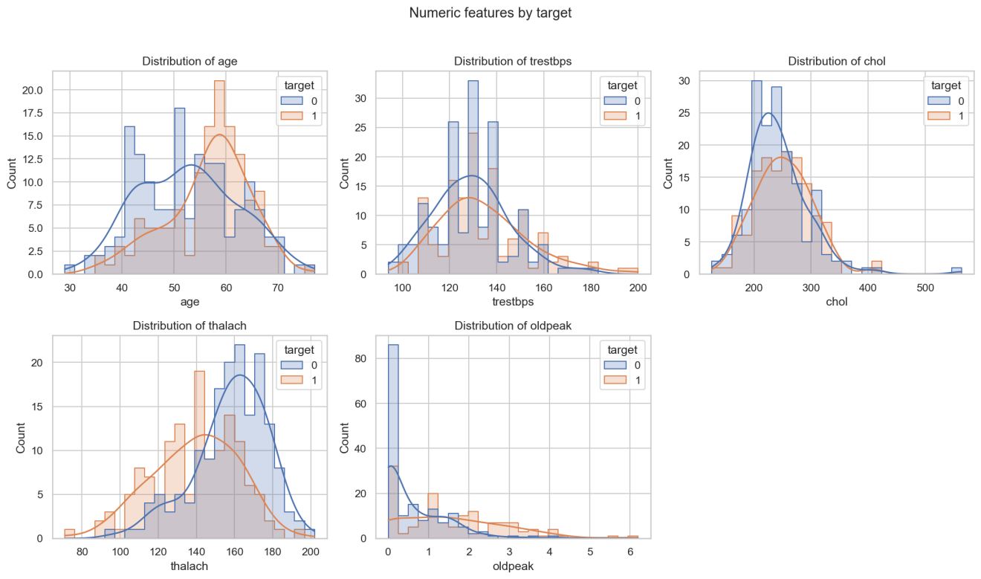
Figure 2. Distributions of the five numeric features, split by target.
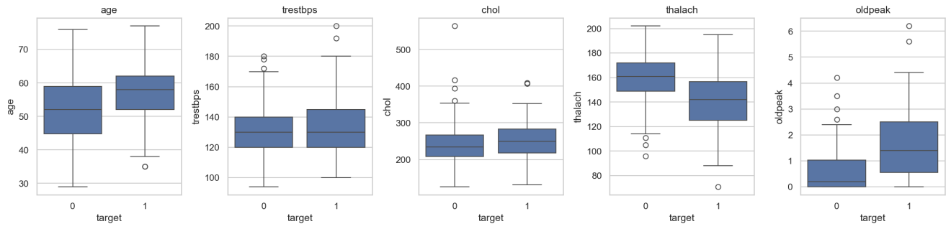
Figure 3. Box plots of the numeric features by target, showing medians and outliers.
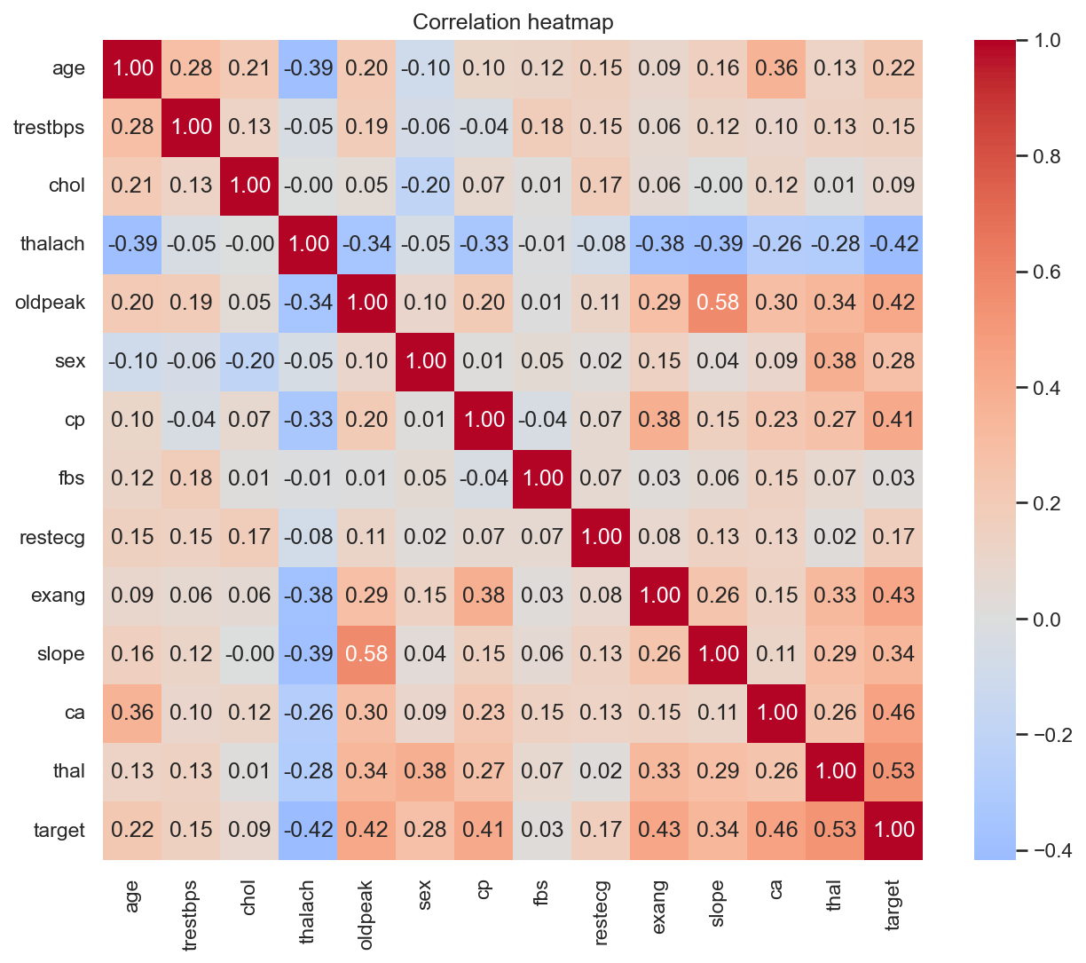
Figure 4. Correlation heatmap of all features and the target.
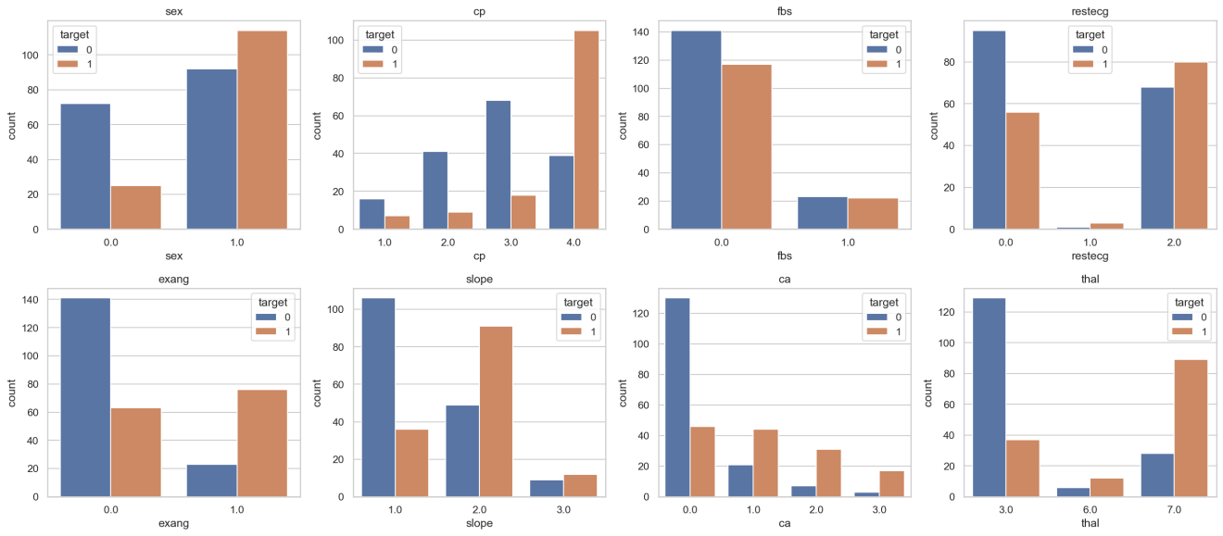
Figure 5. Counts of each categorical feature split by target.
Key observations from the plots:
- Strongest predictors: thal (r = 0.53), ca (0.46), exang (0.43), oldpeak (0.42), cp (0.41) and thalach (-0.42, a lower maximum heart rate goes with disease). chol (0.09) and fbs (0.03) are almost uncorrelated with the target.
- Numeric differences: patients with disease are older (median about 58 against 52), reach a lower maximum heart rate (about 142 against 161) and show higher ST depression (oldpeak median about 1.4 against 0.2). Resting blood pressure and cholesterol look similar in both classes.
- Categorical patterns: disease dominates among patients with asymptomatic chest pain (cp = 4), a reversible-defect thal result (thal = 7), exercise-induced angina and one or more blocked major vessels (ca of 1 or more). Men make up most of the disease cases (about 114 men against 25 women).
- Outliers: a few extreme cholesterol values (up to about 560) and some high blood pressure and oldpeak readings appear in the box plots. They are plausible clinical values, so they were kept, and the median-based imputation and scaling in the pipeline limit their effect.
- Collinearity: the largest correlation between two features is slope and oldpeak at 0.58, which is moderate, so no feature was removed.
- Missing values: only a handful of entries are missing, all in ca and thal, so median or mode imputation inside the pipeline is appropriate.

4. Feature Engineering and Model Development

4.1 Preprocessing pipeline
Preprocessing is built with a scikit-learn ColumnTransformer and lives in src/data_processing.py:
Feature group | Steps
Numeric (5) | median imputation, then standard scaling
Categorical (8) | most-frequent imputation, then one-hot encoding with handle_unknown="ignore"
The preprocessor and the estimator are wrapped in a single Pipeline. The same fitted object is used for training and serving, so there is no training/serving skew.

4.2 Models and tuning
Three classifiers were trained, each tuned with GridSearchCV using stratified 5-fold cross-validation and ROC-AUC as the search metric:
Model | Hyperparameter grid
Logistic Regression | C in {0.01, 0.1, 1, 10}; class_weight in {None, balanced}
Random Forest | n_estimators in {100, 300}; max_depth in {3, 5, None}; min_samples_leaf in {1, 3, 5}
Gradient Boosting | n_estimators in {50, 150}; learning_rate in {0.05, 0.1}; max_depth in {2, 3}
The data is split 80/20 with stratification and a fixed seed of 42. The 20% test set is touched only once per model, for final reporting.

4.3 Model selection
The winner is chosen by mean cross-validated ROC-AUC on the training data, not by test-set performance. Choosing on the test set would give an optimistic estimate, because the same data would be used both to select and to evaluate.

4.4 Results
Results come from models/metrics.json and the MLflow runs. Models were trained on 242 patients and the held-out test set has 61 patients.
Model | CV ROC-AUC (mean ± std) | Test accuracy | Test precision | Test recall | Test F1 | Test ROC-AUC
Logistic Regression | 0.903 ± 0.017 | 0.885 | 0.839 | 0.929 | 0.881 | 0.965
Random Forest | 0.902 ± 0.033 | 0.852 | 0.806 | 0.893 | 0.847 | 0.948
Gradient Boosting | 0.882 ± 0.032 | 0.885 | 0.862 | 0.893 | 0.877 | 0.953
Selected model: Logistic Regression, with C = 0.1 and class_weight = balanced. Its cross-validated scores on the training data were accuracy 0.830, precision 0.823, recall 0.810, F1 0.813 and ROC-AUC 0.903.
Discussion: Logistic Regression and Random Forest are effectively tied on cross-validated ROC-AUC (0.903 against 0.902, far inside one standard deviation of 0.017), and both beat Gradient Boosting (0.882). With a tie, the simpler and more interpretable linear model is a sound choice and is also the cheapest to serve. On the 61-patient test set it reached a ROC-AUC of 0.965 and a recall of 0.929, which means it missed 2 of the 28 patients with disease and raised 5 false alarms. For a screening task, high recall is the better trade-off, and class_weight = balanced pushes the model in that direction. Test scores are higher than the cross-validated ones (accuracy 0.885 against 0.830). With only 61 test patients this is within normal sampling variation, not a sign of leakage, but it means the cross-validated figures are the more dependable estimate of future performance.

5. Experiment Tracking with MLflow
Every training run is logged to MLflow under the experiment heart-disease-classification. Each model has its own run, and a final summary run records the selected model.
Logged item | Content
Parameters | cv_folds, test_size, random_state, scoring metric, train/test sizes, and the best hyperparameters found by the grid search
Metrics | cross-validated mean and standard deviation for accuracy, precision, recall, F1 and ROC-AUC, plus the same five metrics on the test set
Artifacts | confusion matrix and ROC curve plots, the packaged model with signature and input example, and a model-comparison plot in the summary run
Tags | model family and stage
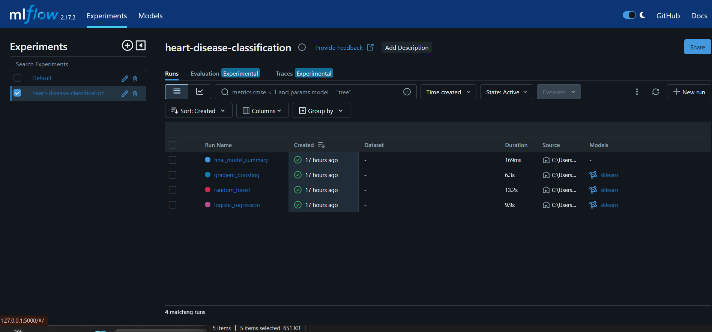
Figure 6. MLflow experiment heart-disease-classification: one run per model plus the final model summary run.
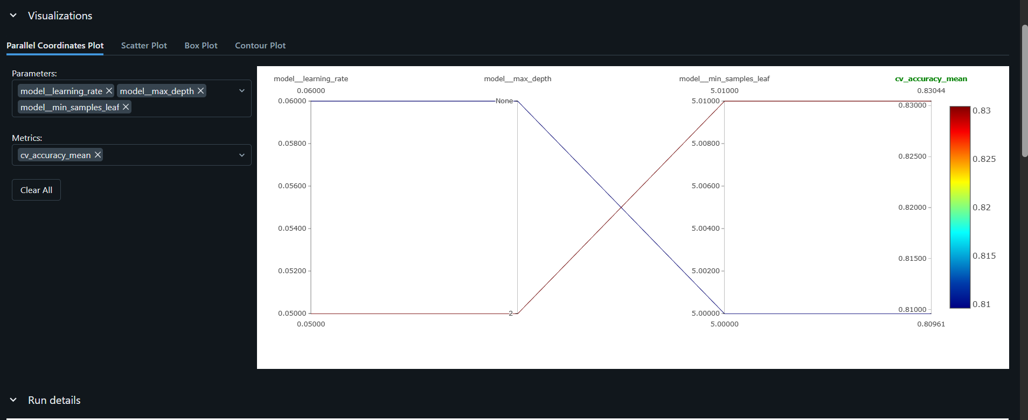
Figure 7. MLflow comparison view: parallel coordinates plot of hyperparameters against cross-validated accuracy.
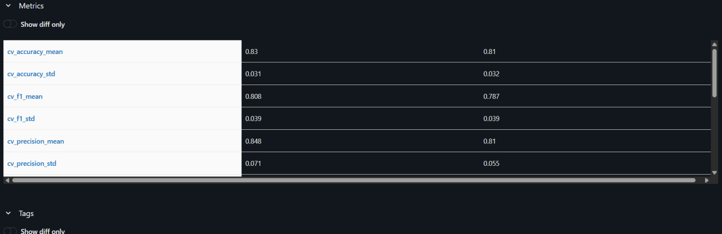
Figure 8. MLflow comparison view: cross-validation metrics of the compared runs side by side.

6. Model Packaging and Reproducibility
- The selected pipeline is saved with joblib to models/model.joblib. Because the preprocessing is inside the pipeline, one file is enough to serve predictions. The MLflow run also stores the model in MLflow format with a signature.
- requirements.txt pins exact versions for the full environment (for example numpy 1.26.4, pandas 2.2.3, scikit-learn 1.5.2, mlflow 2.17.2, fastapi 0.115.4). requirements-serve.txt is a minimal inference-only subset used in the Docker image.
- src/config.py centralises paths, the feature schema, the random seed and the split settings.
- src/predict.py provides command-line inference using the same saved pipeline.
- The whole workflow runs from a clean environment with pip install -r requirements.txt followed by the commands in section 2.3, and CI proves this on every push.

7. CI/CD Pipeline and Automated Testing

7.1 Unit tests
The tests/ folder has 18 pytest tests, all passing:
File | What it covers
test_data_processing.py | target binarisation and handling of ? values, duplicate removal, error on missing columns, X/y split, no NaN after preprocessing, robustness to unseen categories
test_model.py | at least two candidate models exist, the pipeline trains and predicts, every candidate fits, and the metric function returns the right keys and perfect scores on perfect predictions
test_api.py | /health, a valid /predict, rejection of invalid values (negative age, bad sex, thal and cp out of range), rejection of missing fields, and /metrics exposing counters
Coverage is [50]% overall: the API is at about 92% and the data and config modules are covered, while the scripts eda.py, predict.py and most of train.py are exercised by running the pipeline rather than by unit tests.
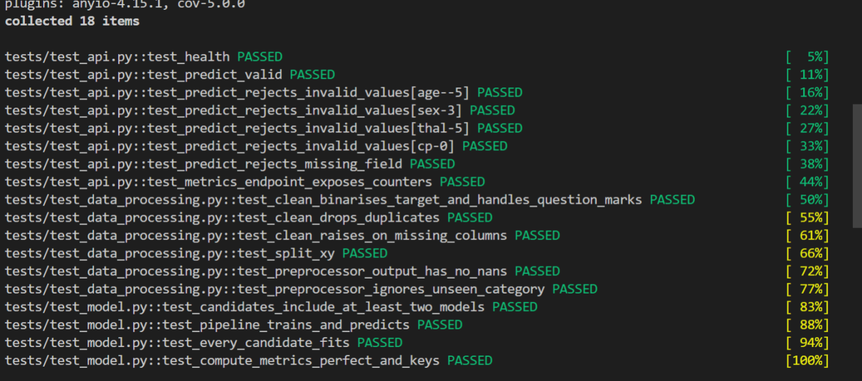
Figure 10. pytest output: all 18 tests pass across the API, data processing and model test files.

7.2 GitHub Actions workflow
The workflow .github/workflows/ci.yml runs on every push and has four dependent jobs:
Job | Purpose | Output
Lint | flake8 src tests scripts | fails the pipeline on style or syntax errors
Unit tests | pytest with coverage and a JUnit report | uploads the test-reports artifact
Train model | downloads data, runs EDA, trains and tracks with MLflow | uploads trained-model and mlruns-and-figures artifacts
Docker | downloads the trained model, builds the image, runs the container, and calls /health, /predict and /metrics through scripts/smoke_test.sh | fails if any call fails
Because each job depends on the previous one, the pipeline stops at the first failure and the logs show which step failed.
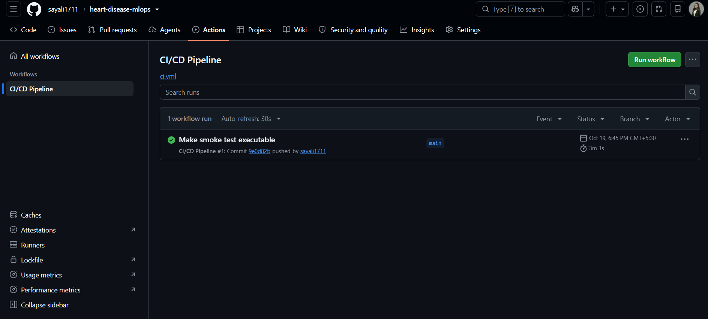
Figure 9. GitHub Actions: the CI/CD Pipeline run on main completed successfully in 3 minutes 3 seconds.

8. Model Containerisation
The API is built with FastAPI (src/api.py) and packaged with the Dockerfile:
- Base image python:3.11-slim, with only the minimal serving requirements installed.
- Only the API code, the config and the trained model are copied in, so the image stays small.
- The app runs as a non-root user and has a HEALTHCHECK that calls /health.

8.1 Endpoints
Endpoint | Method | Purpose
/predict | POST | accepts patient features as JSON and returns the prediction and confidence
/health | GET | liveness and readiness check
/model-info | GET | information about the loaded model
/metrics | GET | Prometheus metrics
/docs | GET | interactive Swagger documentation
Input is validated with Pydantic. Out-of-range values, such as a negative age or an invalid category, are rejected with a 422 response instead of reaching the model.

8.2 Example
curl -X POST http://localhost:8000/predict -H "Content-Type: application/json" -d @sample_input.json
Example response: {"prediction":0,"label":"no heart disease","confidence":0.5402,"probability_disease":0.4598,"request_id":"76b1e948"}

9. Production Deployment on Kubernetes
The API was deployed to a local Kubernetes cluster (Minikube) using the manifests in k8s/:
Manifest | Contents
deployment.yaml | 2 replicas, resource requests (100m CPU, 256Mi) and limits (500m CPU, 512Mi), readiness and liveness probes on /health, and Prometheus scrape annotations
service.yaml | Service of type LoadBalancer exposing port 80 and routing to container port 8000
ingress.yaml | optional Ingress definition
hpa.yaml | optional Horizontal Pod Autoscaler (2 to 5 replicas at 70% CPU)
Deployment steps:
minikube start
minikube image load heart-disease-api:latest
kubectl apply -f k8s/deployment.yaml -f k8s/service.yaml
kubectl get pods,svc
minikube tunnel
The LoadBalancer received the external IP 127.0.0.1 through minikube tunnel. On this Windows machine, the tunnel could not bind port 80 (the restriction on ports below 1024), so the endpoints were verified with kubectl port-forward svc/heart-disease-api 8080:80 and calls to http://localhost:8080/health and /predict. Before this, a local Apache service that held port 80 had to be stopped.

10. Monitoring and Logging

10.1 Logging
A FastAPI middleware logs every request as a JSON line containing a request ID, the endpoint, status and latency. Each prediction is logged as a separate event. Unhandled exceptions are logged with a stack trace and the request ID, so a failed call can be traced.

10.2 Metrics
The API exposes Prometheus metrics at /metrics:
Metric | Type | Meaning
api_requests_total | Counter | requests by method, endpoint and status
api_request_latency_seconds | Histogram | latency per endpoint
api_predictions_total | Counter | predictions served per class
api_errors_total | Counter | unhandled errors
api_model_loaded | Gauge | 1 when the model is loaded

10.3 Dashboards
docker compose up --build starts the API, Prometheus (scraping every 5 seconds) and Grafana, with a data source and a dashboard provisioned from files. The dashboard Heart Disease API has four panels: request rate, p95 latency, predictions by class, and 5xx error rate. Traffic was generated by sending 50 /predict requests.

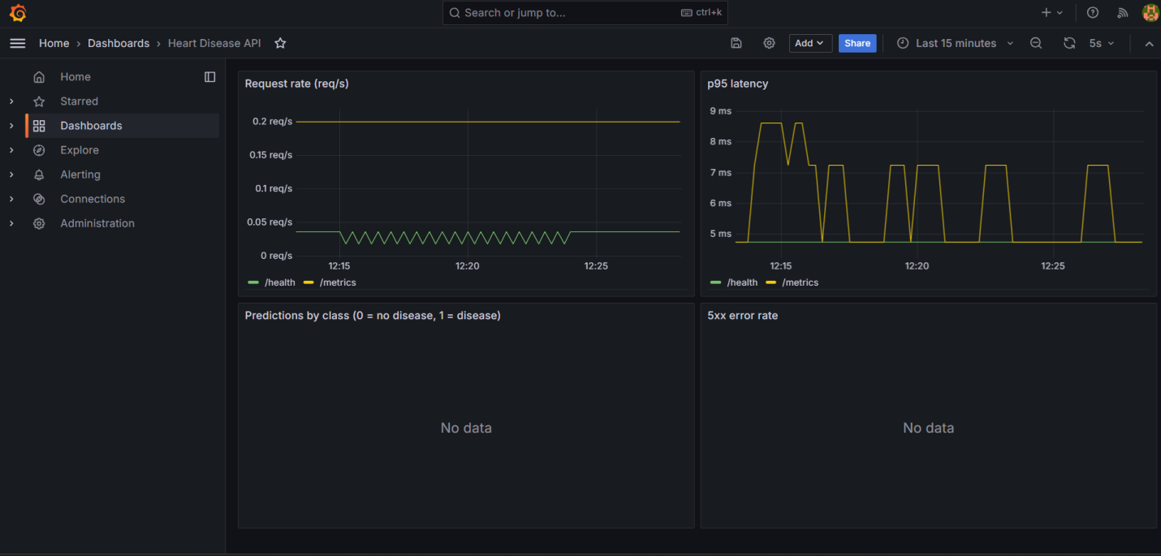11. Architecture

UCI dataset -> download_data.py -> cleaning -> EDA
|
v
src/train.py (pipeline + GridSearchCV)
| |
v v
MLflow tracking models/model.joblib
|
GitHub push -> GitHub Actions (lint, test, v
train, docker) ----------------------> Docker image (FastAPI)
|
v
Kubernetes: Deployment (2 pods) + LoadBalancer Service
|
/metrics v
Prometheus -> Grafana dashboard

12. Design Decisions and Lessons Learned
- Preprocessing inside the pipeline: imputation and scaling are fitted on training folds only, and serving cannot drift from training.
- Selection on cross-validation: this avoids optimistic bias from picking the model on the test set.
- Smoke test in CI: building and calling the container in CI catches packaging errors before deployment.
- Windows deployment issues: [describe what you faced and fixed: Python version and the greenlet build error, the port-80 conflict, Minikube state corruption. Short and honest is best.]
- My own changes: [list what you personally changed or added, such as a different model or grid, an engineered feature, extra dashboard panels, or extra tests.]
- Limitations: the Cleveland dataset has about 300 patients, so metrics have wide uncertainty, and the model is a learning exercise, not a clinical tool.
- Future work: model registry with staged promotion, drift monitoring on input features, deployment to a managed cloud cluster, and HTTPS through an Ingress.

13. Deliverables and Access
Item | Location
GitHub repository | https://github.com/sayali1711/heart-disease-mlops
Screenshots folder | screenshots/ in the repository
Demo video | https://github.com/sayali1711/heart-disease-mlops/tree/main/video
Running the API locally | docker run -p 8000:8000 heart-disease-api:latest, then open http://localhost:8000/docs
Running on Kubernetes | kubectl apply -f k8s/deployment.yaml -f k8s/service.yaml, then kubectl port-forward svc/heart-disease-api 8080:80 and open http://localhost:8080/docs

14. References
- UCI Machine Learning Repository, Heart Disease Data Set (Cleveland).
- scikit-learn, MLflow, FastAPI, Prometheus and Grafana documentation.

